Guide to SATI and ACT Test Scores in the IUIE
Highest Scores and Internal Derived Composite Scores
Last Update: 7/20/2018

Section I: Highest Test Scores

Overview

SATI and ACT test scores in the IUIE are available in two general views. One view is to list all scores for a student, including cases where a student takes the same test on different dates. For examples, see the following report objects:

- DSS.ADM_APPL_TST_SCORE_GT
- DSS_RDS.SR_STU_TST_SCR_GT

In contrast, the view most frequently used at IU for reporting and scholarship selection is the highest test score for each student and test component. Here are some examples of IUIE reports that list only the highest score for each student and test component:

- Current Applications (DSS.ADM_CUR_APPL_GT)
  - IUIE path: Master Catalog → Student → Admissions → Admissions Data → Appls – Current Rows

- SR Student Term (DSS_RDS.SR_STU_TERM_GT)
  - IUIE path: Master Catalog → Student →Records → Student Term → Data Extracts → Student Term

- IR Census/Term Snapshot (DSS_RDS.IR_CEN_TRM_SNPSHT_GT)
  - IUIE path: Master Catalog → Student →Institutional Reporting → Enrollment → IR_CEN_TRM_SNPSHT_GT

See Appendix IV for instructions on how to search the IUIE for all tables and views with the highest ACT and SATI test score columns.

Logic for Selecting Highest Test Scores

Beginning August 1, 2011, the following principles are used to select the highest valid SATI and ACT test scores:

- Only include valid test scores:

  - SATI critical reading, math, writing, reading/writing section, and math section scores
    - Must be a multiple of 10 (end in zero)
    - Range from 200 through 800
    - Must be taken on a date where a valid test score is submitted for both the critical reading and math sections, or for both the reading/writing section and math section scores.

  - SATI essay scores
    - Range from 2 through 12
    - Must be taken on a date where a valid test score is submitted for both the critical reading and math scores, or for both the reading/writing section and math section scores.

  - ACT scores
    - Scores must be an integer (with no decimals)
    - For the writing-only test, the score must range from 2 through 12
    - For the other test components, the score must range from 1 – 36
    - Must be taken on a date where a valid test score is submitted for English, Mathematics, Reading, and Science.
    - Effective 7/29/2011, the derived ACT super composite score is reported externally, in place of the ACT composite score received from ACT or the high school. The derived ACT super composite score is only available in the Warehouse in the IUIE column STU_ACT_C_SCR_NBR. It is not available in the SIS test score table.

- Only include official scores. These have one of these data sources. (Note that the Bloomington campus uses only ACT- and ETS-sourced “agency” data for their internal operations.)

  - ACT (American College Testing service)
  - ETS (Educational Testing Service – SAT)
  - SCH (high school)
  - MF (IU’s legacy student system – mainframe).

- For students who took the SATI test prior to April 1995, IU converts their math and verbal score to the post-1995 scale. These converted scores are included seamlessly in the existing SATI math and critical reading (VE) fields, and they are given equal consideration with the post-1995 scores when determining a student’s highest math and verbal scores. See Appendix III for a list of conversion values.

- All scores that meet the guidelines listed above are considered when selecting the highest test score. Here are some implications:

  - A student’s highest SATI scores may be from different test dates. For example, the highest SATI math score may be from a different test date than the critical reading, writing, and essay SATI scores.

  - Similarly, a student’s highest ACT scores may be from different test dates.

  - Note that no preference is given based on test date.

  - If a student’s SATI math score is 622 (not a multiple of 10) and the critical reading score is 650, neither score is included in the highest test score fields, since the score of 622 is invalid.

  - Self-reported scores are excluded from the highest test scores.

Section II: Derived Test Score Information for Internal Use

For official reporting to the federal government, the State of Indiana, and private surveys, only the highest official test scores are considered (see Section I above for details). The one exception is the new derived ACT super composite score, which replaces the composite score received from ACT, effective 7/29/2011:

Derived test score column for official reporting | Description | Notes | Sample Value
STU_ACT_C_SCR_NBR | Derived ACT Super Composite Score | Rounded average of a student’s highest ACT English (EN), Math (MA), Reading (RE) and Scientific Reasoning (SR) scores. Uses the highest valid scores from the HS or testing agency. Note that effective 7/29/2011, this value no longer matches the ACT composite score (CO) delivered from ACT that is loaded into the SIS test score table. Instead, this derived super composite only exists in the Warehouse data groups described in Appendix IV below. | 30

Otherwise, for internal administrative purposes, these four derived reporting test score fields are available to meet most needs:

Derived reporting test score columns for internal IU use | Description | Notes | Sample Value
STU_DRVD_RPT_SAT_CALC_NBR | Derived SATI Composite Score - Math + Critical Reading (or Math Section + Reading/Writing Section) | SATI VE + MA or ERWS + MSS score. Uses the highest valid scores from the HS or testing agency. | 1350
STU_DRVD_RPT_ACT2SAT_NBR | Derived ACT Super Composite Score converted to the SATI Composite Format | See section above about the derived ACT super composite score. | 1380
STU_DRVD_RPT_SAT_CMPST_NBR | Derived SATI or Converted Derived ACT Super Composite Score (better of the 2) | Highest derived composite from the HS or testing agency, using either SATI derived composite score or conversion of derived ACT super composite score to SATI format. | 1380
STU_DRVD_RPT_SRC_CNV_IND | Derived SATI or Converted ACT Max Composite Indicator | Indicates if the column STU_DRVD_SAT_COMPOSITE_NBR is based on SATI derived composite or the derived ACT super composite score. | ACT

The first and third fields in the table above contain derived scores between 400 and 1600, while STU_DRVD_RPT_ACT2SAT_NBR contains scores between 590 and 1600 (see Appendix II below). The last field contains one of these three values: ACT, SAT2016, or SAT2017. The indicator SAT2016 means that the highest value represents an SATI composite score based on the pre-2017 Math + Critical Reading scores. The indicator SAT2017 means that the highest value represents an SATI composite score based on the post-2016 Math Section and Reading/Writing Section scores. The values for these fields are based on the highest official test scores described in the section above.

The table (IR_DRVD_CMPST_TSTSCR_GT in the IUIE) for converting ACT composite scores to the SAT composite format contains each historical set of conversion crosswalk values. These conversions can be found in Appendix II. See Appendix IV for instructions on how to search the IUIE for all tables and views with these columns.

Here is an illustration of how a student’s highest derived SATI composite score is determined:

Test instance | SATI Math Section | SATI Reading/ Writing Section |  | Notes
1-Dec | 632 | 630 |  | This instance is not reviewed for either the Math Section or Reading/Writing Section score because the Math Section score doesn't end in a zero and is therefore invalid.
1-Oct | 630 | 610 |  | This instance has the highest SATI Math Section score.
1-Jul | 620 | 620 |  | This instance has the highest SATI Reading/Writing Section score.
1-Feb | 820 | 630 |  | This instance is not reviewed because the mathematics score is out of range.
 |  |  | Derived SATI Composite Score
Summary | 630 | 620 | 1250 | The Derived SATI Composite Score is the sum of the two highest components.

Here is an illustration of how a student’s derived ACT super composite score is determined:

Test instance | ACT English | ACT Mathe-matics | ACT Reading | ACT Science | ACT Composite loaded from ACT |  | Notes
January | 38 | 19 | 24 | 22 | 26 |  | This instance is not reviewed because the ACT English score is out of range.
February | 21 |  | 16 | 20 | 20 |  | This instance is not reviewed because the ACT Mathematics score is missing.
April | 600 | 540 |  |  |  |  | This instance is not reviewed because the scores are out of range, and several are missing.
June | 19 | 20 | 23 | 21 | 21 |  | This instance has the highest ACT Reading score.
October | 22 | 22 | 20 | 22 | 22 |  | This instance has the highest ACT English and Science scores.
December | 20 | 23 | 21 | 21 | 21 |  | This instance has the highest ACT Mathematics score.
 | Highest  ACT English | Highest ACT Mathe-matics | Highest ACT Reading | Highest ACT Science | Derived ACT Super Composite | Derived ACT Super Composite Score – Converted to SAT Format
ACT Summary | 22 | 23 | 23 | 22 | 23 | 1070 | The highest ACT test components are summed, divided by four, and rounded to an integer (23). This derived ACT super composite score is converted to 1070, based on Appendix II below, and will be compared to the SATI derived composite score of (620 + 630) 1250. The SAT score will be selected for this field because it is higher.

The Derived SATI or Converted ACT Max Composite Score (STU_DRVD_RPT_SAT_CMPST_NBR) is 1250 in this case. This is the higher of the Derived SATI Composite Score and the Derived ACT Super Composite Score - SAT Format. The column STU_DRVD_RPT_SRC_CNV_IND is set to SAT2017, since the source of the 1250 score is the SATI Math Section + Reading/Writing Section scores.

Keep in mind that the values from the columns STU_DRVD_RPT_SAT_CALC_NBR (1250), STU_DRVD_RPT_ACT2SAT_NBR (1070) and STU_DRVD_RPT_SAT_CMPST_NBR (1250) are not reported officially to external agencies, but may be used internally.

Section III: For more information

More information about the SATI and ACT scores can be found on these websites:

http://www.act.org/content/act/en/products-and-services/the-act/scores/act-sat-concordance.html https://collegereadiness.collegeboard.org/educators/higher-ed/scoring/concordance

If you have additional questions, please contact University Institutional Research and Reporting by using the form on our website: https://uirr.iu.edu/contact/info-request/ .

Appendices

Appendix I: IUIE table columns related to derived composite scores on the SATI scale.

case when trunc(sysdate) < to_date('01/01/2017','mm/dd/yyyy') then STU_DRVD_SAT_COMPOSITE_NBR
when trunc(sysdate) < to_date('08/28/2018','mm/dd/yyyy') then STU_2017_DRVD_SAT_CMPST_NBR
else STU_2019_DRVD_SAT_CMPST_NBR end as STU_DRVD_RPT_SAT_CMPST_NBR,
case when trunc(sysdate) < to_date('01/01/2017','mm/dd/yyyy') then STU_DRVD_SAT_OR_ACT_CNV_IND
when trunc(sysdate) < to_date('08/28/2018','mm/dd/yyyy') then STU_2017_DRVD_SRC_CNV_IND
else STU_2019_DRVD_SRC_CNV_IND end as STU_DRVD_RPT_SRC_CNV_IND,
case when trunc(sysdate) < to_date('01/01/2017','mm/dd/yyyy') then STU_SAT_CALC_COMPOSITE_NBR
when trunc(sysdate) < to_date('08/28/2018','mm/dd/yyyy') then STU_2017_SAT_CALC_NBR
else STU_2019_SAT_CALC_NBR end as STU_DRVD_RPT_SAT_CALC_NBR,
case when trunc(sysdate) < to_date('01/01/2017','mm/dd/yyyy') then STU_ACT_TO_SAT_MAX_NBR
when trunc(sysdate) < to_date('08/28/2018','mm/dd/yyyy') then STU_2017_ACT2SAT_MAX_NBR
else STU_2019_ACT2SAT_MAX_NBR end as STU_DRVD_RPT_ACT2SAT_NBR,

case when trunc(sysdate) < to_date('01/01/2017','mm/dd/yyyy') then STU_AGNCY_DRVD_SAT_CMPST_NBR
when trunc(sysdate) < to_date('08/28/2018','mm/dd/yyyy') then STU_AGNCY2017_DRV_SATCMPST_NBR
else STU_AGNCY2019_DRV_SATCMPST_NBR end as STU_DRVD_AGNCYRPT_SATCMPST_NBR,
case when trunc(sysdate) < to_date('01/01/2017','mm/dd/yyyy') then STU_AGNCY_DRVD_SAT_ACT_CNV_IND
when trunc(sysdate) < to_date('08/28/2018','mm/dd/yyyy') then STU_AGNCY2017_DRVD_SRC_CNV_IND
else STU_AGNCY2019_DRVD_SRC_CNV_IND end as STU_DRVD_AGNCYRPT_SRC_CNV_IND,
case when trunc(sysdate) < to_date('01/01/2017','mm/dd/yyyy') then STU_AGNCY_SAT_CALC_CMPST_NBR
when trunc(sysdate) < to_date('08/28/2018','mm/dd/yyyy') then STU_AGNCY2017_SAT_CALC_NBR
else STU_AGNCY2019_SAT_CALC_NBR end as STU_DRVD_AGNCYRPT_SATCALC_NBR,
case when trunc(sysdate) < to_date('01/01/2017','mm/dd/yyyy') then STU_AGNCY_ACT_TO_SAT_MAX_NBR
when trunc(sysdate) < to_date('08/28/2018','mm/dd/yyyy') then STU_AGNCY2017_ACT2SAT_MAX_NBR
else STU_AGNCY2019_ACT2SAT_MAX_NBR end as STU_DRVD_AGNCYRPT_ACT2SAT_NBR,

Appendix II: Table for converting ACT composite scores to the SATI composite format
(Based on conversions stored in IR_DRVD_CMPST_TSTSCR_ST)

ACT composite | SATI composite (VE + MA) – Before 7/31/2009 | SATI composite (VE + MA) - 7/31/2009 through fall 2016 reporting | SATI composite (VE + MA or ERWS + MSS) – spring 2017 through fall 2018 reporting | SATI composite (VE + MA or ERWS + MSS) - Beginning with spring 2019 reporting
9 |  |  |  | 590
10 |  |  |  | 630
11 | 500 | 530 | 590 | 670
12 | 560 | 590 | 680 | 710
13 | 620 | 640 | 740 | 760
14 | 680 | 690 | 780 | 800
15 | 740 | 740 | 830 | 850
16 | 780 | 790 | 870 | 890
17 | 830 | 830 | 910 | 930
18 | 870 | 870 | 950 | 970
19 | 910 | 910 | 990 | 1010
20 | 950 | 950 | 1030 | 1040
21 | 990 | 990 | 1070 | 1080
22 | 1030 | 1030 | 1110 | 1110
23 | 1070 | 1070 | 1140 | 1140
24 | 1110 | 1110 | 1180 | 1180
25 | 1140 | 1150 | 1220 | 1210
26 | 1180 | 1190 | 1260 | 1240
27 | 1220 | 1220 | 1290 | 1280
28 | 1260 | 1260 | 1320 | 1310
29 | 1300 | 1300 | 1360 | 1340
30 | 1340 | 1340 | 1400 | 1370
31 | 1380 | 1380 | 1430 | 1400
32 | 1420 | 1420 | 1470 | 1430
33 | 1470 | 1460 | 1500 | 1460
34 | 1520 | 1510 | 1540 | 1500
35 | 1580 | 1560 | 1570 | 1540
36 | 1600 | 1600 | 1600 | 1590

Appendix III: Table for converting pre-April 1995 SATI math and verbal scores to the post-1995 scale

The following tables were downloaded from this College Board website, which is no longer maintained: http://professionals.collegeboard.com/data-reports-research/sat/equivalence-tables/sat-score

Verbal |  | Verbal
Original | Recentered | Original | Recentered
800 | 800 | 500 | 580
790 | 800 | 490 | 570
780 | 800 | 480 | 560
770 | 800 | 470 | 550
760 | 800 | 460 | 540
750 | 800 | 450 | 530
740 | 800 | 440 | 520
730 | 800 | 430 | 510
720 | 790 | 420 | 500
710 | 780 | 410 | 490
700 | 760 | 400 | 480
690 | 750 | 390 | 470
680 | 740 | 380 | 460
670 | 730 | 370 | 450
660 | 720 | 360 | 440
650 | 710 | 350 | 430
640 | 700 | 340 | 420
630 | 690 | 330 | 410
620 | 680 | 320 | 400
610 | 670 | 310 | 390
600 | 670 | 300 | 380
590 | 660 | 290 | 370
580 | 650 | 280 | 360
570 | 640 | 270 | 350
560 | 630 | 260 | 340
550 | 620 | 250 | 330
540 | 610 | 240 | 310
530 | 600 | 230 | 300
520 | 600 | 220 | 290
510 | 590 | 210 | 270
 |  | 200 | 230

Math |  | Math
Original | Recentered | Original | Recentered
800 | 800 | 500 | 520
790 | 800 | 490 | 520
780 | 800 | 480 | 510
770 | 790 | 470 | 500
760 | 770 | 460 | 490
750 | 760 | 450 | 480
740 | 740 | 440 | 480
730 | 730 | 430 | 470
720 | 720 | 420 | 460
710 | 700 | 410 | 450
700 | 690 | 400 | 440
690 | 680 | 390 | 430
680 | 670 | 380 | 430
670 | 660 | 370 | 420
660 | 650 | 360 | 410
650 | 650 | 350 | 400
640 | 640 | 340 | 390
630 | 630 | 330 | 380
620 | 620 | 320 | 370
610 | 610 | 310 | 350
600 | 600 | 300 | 340
590 | 600 | 290 | 330
580 | 590 | 280 | 310
570 | 580 | 270 | 300
560 | 570 | 260 | 280
550 | 560 | 250 | 260
540 | 560 | 240 | 240
530 | 550 | 230 | 220
520 | 540 | 220 | 200
510 | 530 | 210 | 200
 |  | 200 | 200

Appendix IV: IUIE report objects with students’ highest ACT and SATI test scores

Follow these steps to search the IUIE for tables and views with students’ highest ACT and SATI scores:

- Log into the IUIE and navigate to the Master Catalog.

- In the Search box in the upper right corner, type the technical name of a table or view (e.g. SR_STU_TERM_GT) that includes students’ highest ACT and SATI scores, and then click on the Search button.

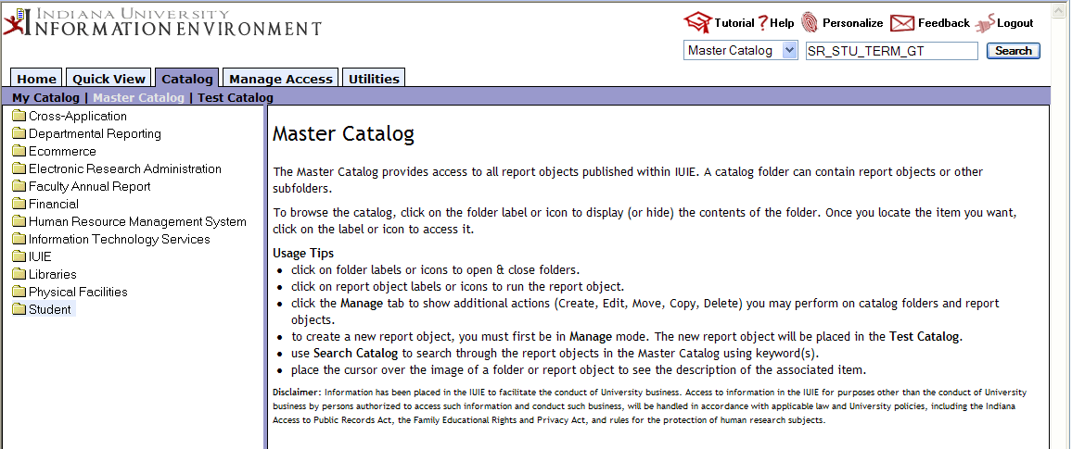

- Scroll down through the search results until you see the name of the table or view that you searched for. Use your mouse to click on the underlined name of the table or view. This will take you to that report object. (See the illustration on the next page.)

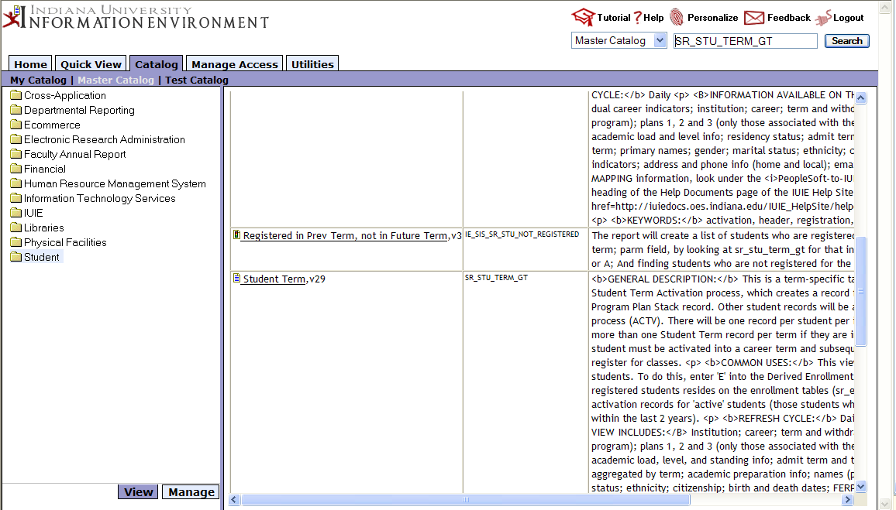

- You may be presented with a secondary screen with different locations for the same table or view. Pick any one of these by clicking on the underlined name of the report object.

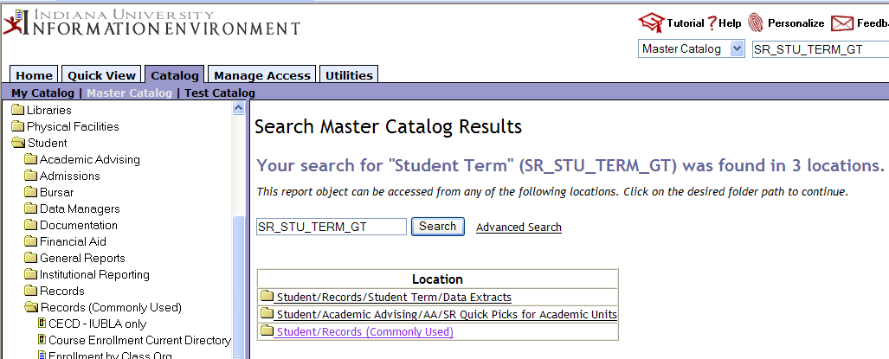

- Once in the report object, scroll down until you find one of the highest test score column names. (See the illustration on the next page.)

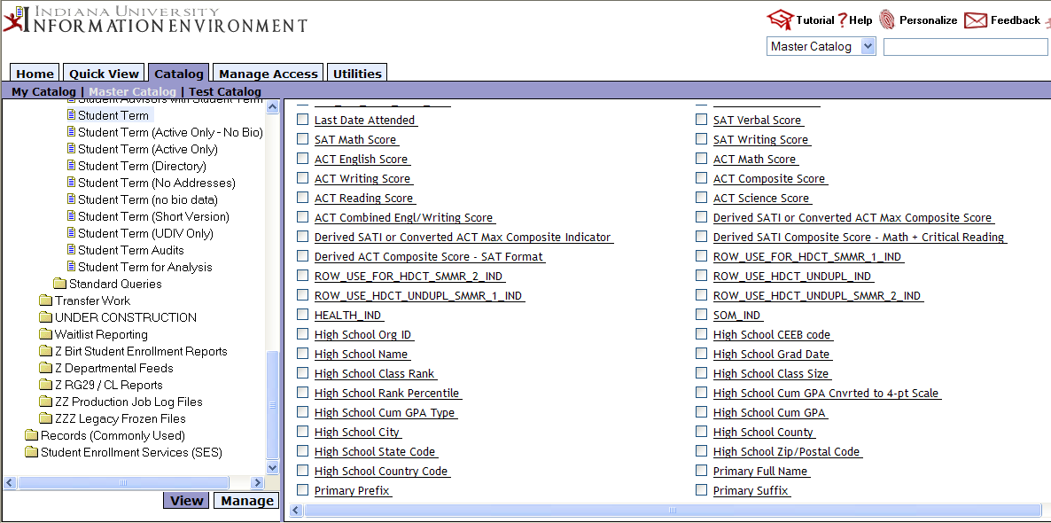

- Click on the underlined column name that you desire. You will then see a display of all tables and views with this column.

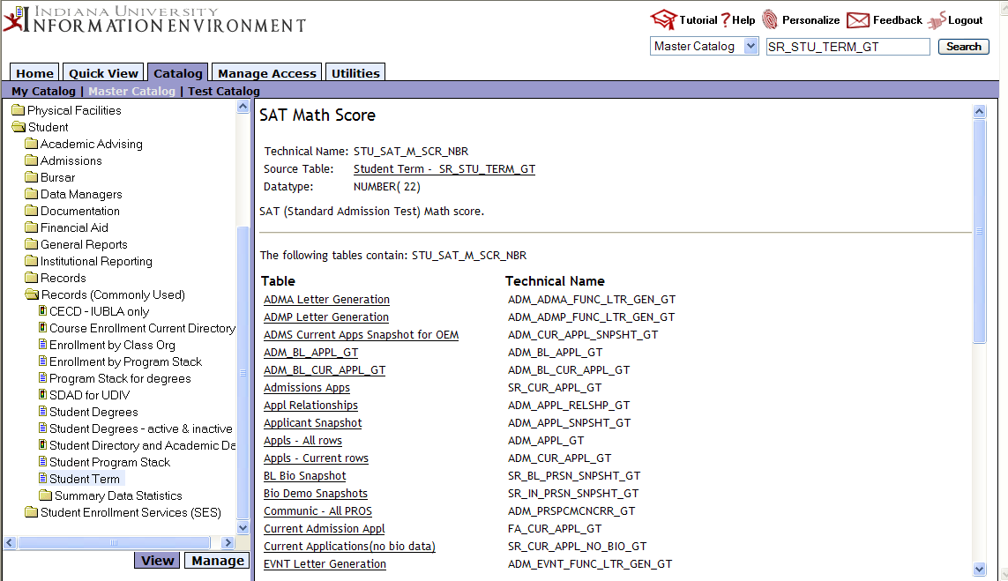

- In addition, some Pre-defined Queries (PDQ’s) in the IUIE may include these columns. Here is a list of PDQs with the highest SATI and ACT score columns as of summer 2016:

ie_sis_sr_bl_retention.sqr
ie_sis_sr_majors_extract.sqr
ie_sis_sr_retention.sqr
ie_sis_sr_student_profile_report.sqr
ie_sis_sr_stu_term_subplans.sqr
ie_sis_sr_enrl_cls_rpt.sqr
ie_sis_adm_adma_comm.sqr
ie_sis_adm_admp_comm.sqr
ie_sis_adm_crm_data_load_ea.sqr
ie_sis_adm_pros_comm.sqr
ie_sis_adm_stat_lbl.sqr
ie_sis_adm_zero_gpa_qual.sqr
ie_sis_fa_compass_appl_sum_2013.sqr
ie_sis_fa_compass_appl_sum.sqr
ie_sis_fa_fndtn_schlshp_sprdsht.sqr
ie_sis_fa_mary_sinclair_schlrs.sqr
ie_sis_fa_oem_nmd_awd_schlrshps.sqr
ie_sis_fa_schlrs_slct_freshman.sqr
ie_sis_fa_schlrs_slct.sqr
ie_sis_fa_ssa_fin_aid.sqr

Note that admissions offices may need to use converted composite scores from a particular time period for term-specific admissions activities. The four fields listed in the table above and continuing on the next page are derived from those term-specific fields based on the date when the user accesses the data warehouse. A full list of the various derived composite scores can be found in Appendix I below.
See the companion IR Data Guide Excel spreadsheet for information about the SATI redesign that took place in 2016 and became effective in spring 2017 at IU: uirr.iu.edu/resources/ir-data-guides/ > SAT Redesign (2016) Technical Documentation

